A Methodological Approach for Supporting Socio-Hydrological Modelling of a Complex Nexus System
Claudia PANCIERA¹, Alessandro PAGANO², Raffaele GIORDANO², Ivan PORTOGHESE², Mert Can GUNACTI³, Sefa Nur YESILYURT³, Mohamed NAJAR⁴, Cem Polat CETINKAYA³, Gulay ONUSLUEL GUL³, Estrella LOPEZ⁵, Manuel BEA⁵
¹ DICATECh, Politecnico di Bari, Bari, Italy; c.panciera@phd.poliba.it
^{2,} Water Research Institute-National Research Council (CNR-IRSA), Bari, Italy; alessandro.pagano@cnr.it raffaele.giordano@cnr.it , ivan.portoghese@cnr.it ,
³ Dokuz Eylul University, Faculty of Engineering, Department of Civil Engineering, Izmir, Turkey, mert.gunacti@deu.edu.tr , sefanur.yesilyurt@deu.edu.tr , cem.cetinkaya@deu.edu.tr , gulay.onusluel@deu.edu.tr
⁴ GIS Department, Islamic University of Gaza, Gaza, Palestine; eng.mhmd.najar@gmail.com ,
^{5,} Asociaciòn ECOADAPTA, Madrid, Spain, estrellalm@ecoadapta.org , manuelbm@ecoadapta.org
Abstract
The Water-Ecosystems-Food Nexus is increasingly studied and adopted both in the research and in the policy fields, since there is evidence of the side effects of sectoral policies implemented without considering any cross-sectoral analysis (Sušnik et al., 2021). In a scenario of accelerated changes, both from a climatic and socio-economic point of view (demographic and economic expansion), natural resources such as water are constantly threatened by competing multiple sectors such as agriculture, tourism, industry and environment (Karamouz et al., 2021). The complexity of natural resources management becomes more critical in areas where natural reserves are jeopardized by human action, such as the Doñana National Park, a coastal area in SW Spain where the environmental and economic interests have varied over time with increasing contrasts among stakeholders. The LENSES project is operating in the Doñana area (as one of the case studies in the Mediterranean area), with the objective to propose a new approach based on Participatory System Dynamic Modelling (PSDM) to recognize the major challenges and the drivers for the system, ultimately suggesting potential actions/strategies, using a Nexus approach. Our work focuses on the assessment of the system under current and future conditions, integrating PSDM with other sectoral models (in particular, hydrological modeling and water resources allocation). This integrated model supports decision making processes in view of the implementation of Nexus approaches, to make the system resilient and more sustainable over time.

- Introduction
In a historical period denoted by very strong demographic expansion and economic growth, challenges for the allocation and management of the water resource are increasingly articulated. Such a period with its infrastructural and technological expansion has been so much impacting on natural resources with pressure in any sector, including water use, that it is precisely named "Anthropocene" (Falkenmark et al., 2018). When the resource is used in one sector, such as irrigation for food production, it is obviously taken away from other sectors, such as ecosystem services or urban water supply (De Roo, 2021). It is for this reason that it is no longer possible to study or manage a resource by referring to a single area of use, but these must be studied by cross-sectoral analysis both from the perspective of scientific research and from the consequent field of policies (Sušnik et al., 2021). Therefore, the Nexus approach can be focused on various natural and anthropogenic aspects, and in this study, the Water-Ecosystems-Food Nexus is specifically investigated. In addition to managing the conflict between the various components already known such as agriculture, tourism, industry, environment, and urban supply, one of the greatest challenges of the Nexus is to cope with climate change and its unknown impacts in conjunction with other factors such as demographic pressure (Buytaert et al., 2012). Implementing Nexus-based solutions is even more complex but necessary in areas where the environmental component is substantial but constantly threatened by anthropization. A striking example in this sense are wetlands which are delicate areas scattered all over the planet that provide significant ecosystem services though they are often characterized by the lack of gauges for the identification of trends and implementation of conservation measures to contrast climate variability and to define adaptation policies (Erwin, 2009; Gallant, 2015). In such contexts, more than in others, it is necessary to implement suitable models to support management strategies, which are as inclusive as possible of all the parties involved. In this article, this modelling effort is implemented in the case of Doñana Natural Park, a coastal area in SW Spain overlooking the Atlantic Ocean, which is among the pilot cases of the LENSES project with the aim of developing a Participatory System Dynamics Modelling (PSDM) for the implementation of inter-sectoral strategies for the integrated water resources management. This type of modelling needs an integrated approach, composed of the combination of sectoral models that not only allow framing and management of the current situation but also the evaluation of scenarios and comparison between them to obtain optimal solutions for the future management of the water resource. In this context, HEC-HMS and WEAP software are used to model the rainfall-runoff processes and water allocation practices realized in the study area. The U.S. Army Corps of Engineers developed the open-source, physically based HEC-HMS rainfall-runoff model (http://www.hec.usace.army.mil/software/hec-hms). It has been a staple for researchers to investigate event-based or continuous rainfall-runoff processes (Hamdan et al., 2021; Sahu et al., 2023). The results of the HEC-HMS have been integrated then into the WEAP water allocation model, which has been developed by the Stockholm Environment Institute (SEI) (Yates et al., 2005). WEAP allows users to define and model complex water allocation topologies with built-in models to calculate various processes such as evaporation, snow-melt, crop water requirement, surface/groundwater interaction and etc. In this study, the criticalities found in linking the various models are analyzed and some solutions and preliminary output from each type of model are presented.

- The case-study
The Doñana region, which covers one of the most important wetlands in Europe, is an area between the Tinto River and Guadiamar River estuary and overlooks the Atlantic. Placed in southwest Spain, the area includes the provinces of Huelva, Sevilla, and Cadiz. The climatic area is Mediterranean, characterized by a sub-humid climate with mild winters (4.6°C on average for January) and very hot summers (34°C in July). The average precipitation is 540 mm/yr, but this is relatively indicative because the area, under the influence of Atlantic currents, is characterized by a great climatic variability with dry years followed by an extremely rainy and above-average year, or vice versa (Green et al., 2016). Climate variability plays a great role for the purposes of this study as this aspect reflects on various processes making this socio-hydrological system particularly complex to analyze. Due to its geological and morphological conformation straddling two continents, in which water constitutes the main element of feeding and connection, Doñana hosts natural areas with different characteristics such as marshland, coastal temporary lagoons protected by dunes of stabilized sands, areas with varied vegetation (grasslands, woodlands, scrublands) (Aldaya et al., 2010). It is historically considered a place of high naturalistic value as well as a notable biodiversity hub straddling two continents (Serrano, 2016). For decades, the Spanish government has placed under protection the area making it National Park (1969) and Natural Park (1989) extending its protected area over time. International safeguards are added to this, such as the Biosphere Reserve Declaration (1980), the inclusion in the Ramsar wetland list (1982), the Natura 2000 Network (1987), and the designation in 1994 by UNESCO as a World Heritage Site. Nowadays it is under protection by important institutions such as the WWF, as it has undergone different anthropogenic pressures over time such as channel diversion, and the overexploitation of surface and underground water bodies due to the increased water demand for irrigation and tourism. The effects of this exploitation regime are tangible, and, without a clear and coherent action plan, the situation can only become worse. Following a chronological order, the first changes by humans occurred in the 50s and 60s when the flows that reached the marshland were diverted to permanently drain the area and make it available for cultivation. A large part of the marshland has been used for rice cultivation, and Doñana is still one of the largest rice fields in Europe. Following the emergence of new techniques of water extraction and irrigation, the natural area was, starting from the 90s, surrounded by massive water-demanding crops (such as berries cultivated in greenhouses) just outside the protected area: this event has led to a significant increase in groundwater abstractions both legal and illegal therefore not monitored, and gradually, threaten water bodies and nourishment of ecosystems. Because of the extraordinary beauty and uniqueness of the places, the area has been also targeted by naturalistic and religious tourism and, especially near the coast, several resorts have been placed that also record large withdrawals from groundwater whose effect is the depletion of ecosystems such as temporary lagoons (Dìaz-Paniagua et al, 2015; Naranjo_Fernandez et al., 2018; Naranjo-Fernandez et al., 2020; Green et al., 2024). The Doñana aquifer system, divided into five units for geological and administrative issues (La Rocina, Marismas, Marismas de Doñana, Almonte, Manto Eolico Litoral de Doñana), has been analyzed both quantitatively and qualitatively by the Guadalquivir Hydrographic Confederation (CHG). This work led, in the Guadalquivir Water Management Plan 2022-2027 (CHG, 2023), to designate three of the five aquifers as being in a "poor quantitative state" because of the overexploitation related to various human activities. Figure 1 shows the average water balance components for each of the five aquifers, together with the calculation of the Groundwater Exploitation Index (GEI) (Portoghese et al., 2013) from which it is clear which of them are over-exploited and therefore need specific conservation measures.

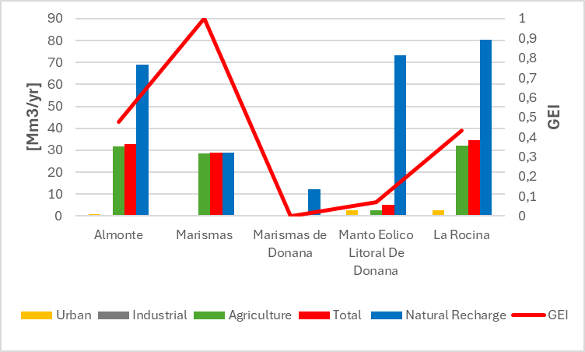

Fig. 1. Sectoral water uses and GEI for Doñana aquifers.

Even the industrial sector, although not really located in the vicinity of protected areas, has affected the natural resources in the Doñana territory, since the accidental collapse of the Aznalcollar dam embankment in 1998 which released large quantities of toxic sludge from the nearby mining industry in the Guadiamar River, and forced local authorities to further disconnect the natural drainage system feeding the marshland from the upstream river basins. These environmental issues have been followed over time by several proposals for protection and restoration actions whose effectiveness was critically hampered by the intrinsic complexity of this socio-hydrological system and the lack of adequate surveys and measurements (e.g. knowledge of the extent of illegal withdrawals or still in-depth knowledge of groundwater masses). Under such conditions, an adequate knowledge of the dominant sectoral processes for this territory could be achieved through suitably integrated models that combine the physical dynamics of this environment with the human and socio-economic dimensions. For about 3 years within the activities of the LENSES Project, the modelling activity regarding the Doñana region has involved tens of stakeholders and local experts in the definition of a suitable framework inspired by the water-ecosystem-food nexus approach to evaluate possible sustainability scenarios including socio-economic and climate change likely trajectories. This modelling process and its most relevant outcome are briefly presented in the following sections.

- Methodology
The value added of the modelling approach presented in this work is the direct involvement of stakeholders in SDM development and analysis processes (Fig. 2). In this regard, a series of individual interviews and workshops have been organized throughout the project duration to elicit stakeholder knowledge on the main challenges over the area, ultimately feeding the Causal Loop Diagram (CLD). The CLD was used to get a holistic perspective on the system under investigation, helping to analyze in a structured way the conflicts between intensive water users (such as green-house farmers) and environmental organizations interested in the protection of marshland ecosystems. In particular, during the first workshop a participatory mapping exercise was performed, to represent the complexity of the main processes (including bio-physical, socio-economic, and behavioral variables) characterizing the study area. Stakeholders helped identify the main processes, the central variables, and critical interdependencies, supporting the definition of a comprehensive system picture.
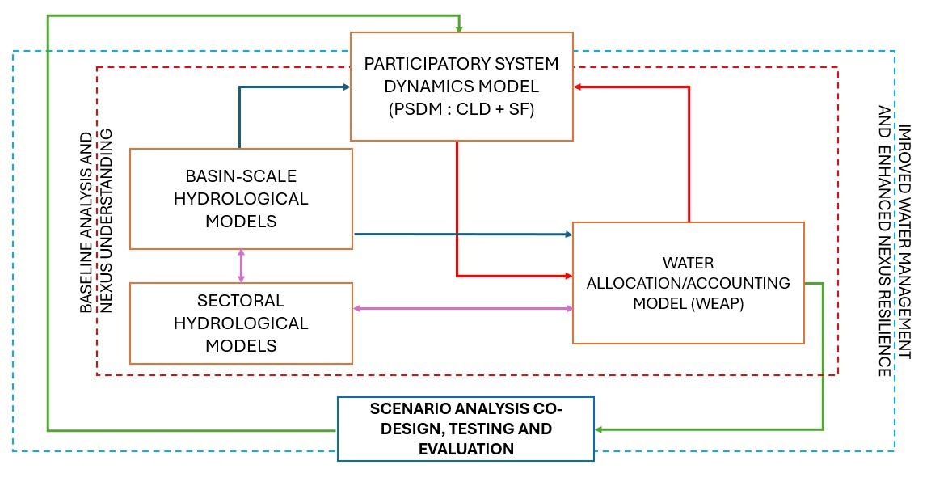
Fig. 2. Operating scheme of integrating modelling

A physically based modelling (HEC-HMS) was used in parallel to the stakeholder engagement to characterize the surface hydrological response of the whole study area. This type of model used hydrological input data such as temperatures, rainfall, land cover, elevation data, and available flow data records (Gil Gil et al., 2024) to define the surface hydrology (rainfall-runoff process) of the entire analyzed region (3,723 km²). Concerning groundwater resources, a key challenge identified for the area was the unsustainable exploitation of aquifers reducing the river baseflow. The hydrological model’s output produced at the basin-scale informed the Participatory System Dynamics Model (PSDM) and the water allocation modelling. In particular, the WEAP model, was used to evaluate intersectoral water demand-supply relationships. This type of model, unlike the CLD, which has a qualitative aspect, allows one to obtain quantitative outputs related to specific spatial features using the topological scheme already identified in the CLD. The sources of supply and demand are expressed through nodes connected by links. Since CLDs are patterns that highlight cause/effect relationships, it is possible to use them to highlight the main conflicts in the study area to conduct the analysis in a structured manner. Through the CLD, the PSDM is able to dialogue with the sectoral models such as water allocation/accounting. The analysis of the CLD supported the central role of water security for the state of the area, while WEAP was used to investigate water management options and the need to undertake strategies for the restoration of the different natural ecosystems (marshland and temporary lagoons) and for the protection of biodiversity over the whole area. The WEAP model included demand and supply nodes and was focused here on the description (in a quantitative form) of the environmental water demand within the water balance of the area. Figure 3 represents the WEAP scheme of the case study: as can be seen, the diagram shows the main streams of the area whose discharge rates were estimated from hydrological modelling. The demand points were not divided by municipalities but rather according to the abstractions from the five water bodies underlying the area. For supply points also, groundwater was schematized based on data provided in official reports (CHG, Guadalquivir Hydrographic Confederation). From the analyses conducted through WEAP modelling, multiple results were obtained: first quantitative outputs useful to the PSDM were obtained and, on the other hand, the urgent need to quantify the environmental water requirements was highlighted. In particular, the water allocation modeling allowed identifying the unmet water demand of the Doñana marshland during dry and ordinary years based on the historical climate records. Figure 3 represents nodes as "Marshland Demand" and "Temporary Lagoons Demand" for which it was not possible to obtain quantitative estimation that would contribute to the assessment of sustainability of the entire system. In this regard, the participatory process, encompassing challenges and objectives of various stakeholders, resulted in a consensual need for developing a robust quantitative tool for the evaluation of the marshland water balance, enabling to investigate the environmental water requirements of Doñana coastal plain under different management scenarios. In this direction, we envisage the integration of the water allocation model with the PSDM (specifically, building a stock and flow model), in order to perform a ‘what-if’ scenario analysis able to consider the role of multiple drivers (e.g., climate change) and the impact of the suggested strategies. In these scenarios, the impact of external forces such as climate change is considered, as well as the effects of behavioral drivers derived from the workshop. Mitigation and control strategies proposed by experts and also discussed with stakeholders (Nature Based Solutions, water allocation criteria, etc.) need to be to analyzed both on the technical field and the participatory one in order to become a basis for the subsequent implementation of policies for the territory. The stage of scenarios’ realization described above constitutes a step after the basic knowledge of the Nexus processes, obtained as a result of the described models; in turn, however, can be also an input for new, more advanced participatory analyses.
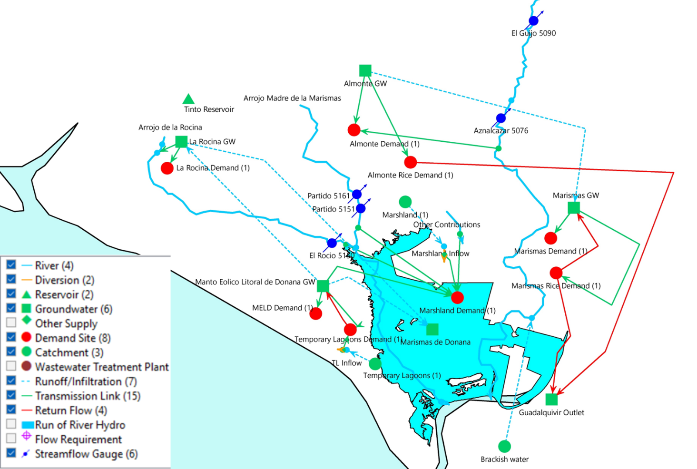

Fig. 3. The WEAP scheme of Doñana 's case study.

- Results
This section describes the main results obtained so far through the modelling approach presented above with the main strength points and limitations. In particular, being the dynamic participatory process is still ongoing, we will discuss the outputs limitedly to WEAP allocation and account modelling. As far as concerns aquifer exploitation, one of the main causes of water conflict in the area, the analysis focused on groundwater nodes and the related demand nodes. Assuming constant water demand over time, and thus without proposing mitigation measures, the impact of climate change on groundwater storage is evaluated. Figure 4 shows the variability of groundwater storage for 3 of the main aquifer systems in the study area under present (historical data from 2015 to 2018) and future climate scenarios (RCP4.5 and RCP8.5 climate scenario, time slice 2022-2100), highlighting no trend for La Rocina aquifer, increasing variability for Almonte, and decreasing storage for the more critical Marismas aquifer.

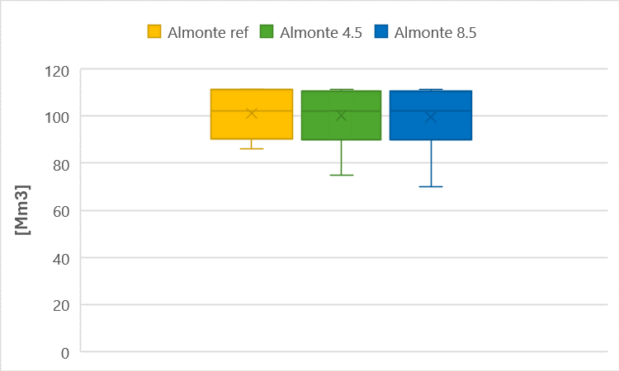
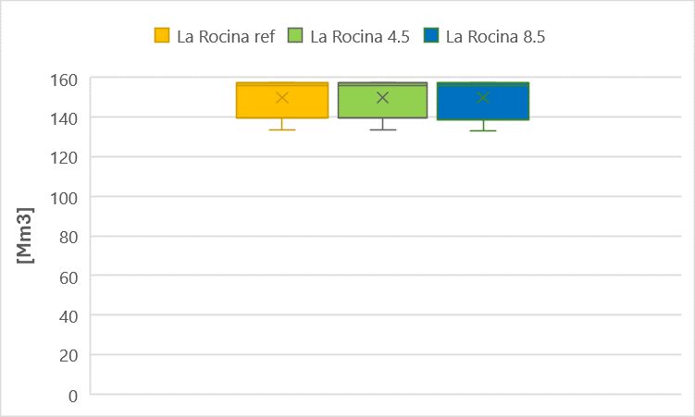

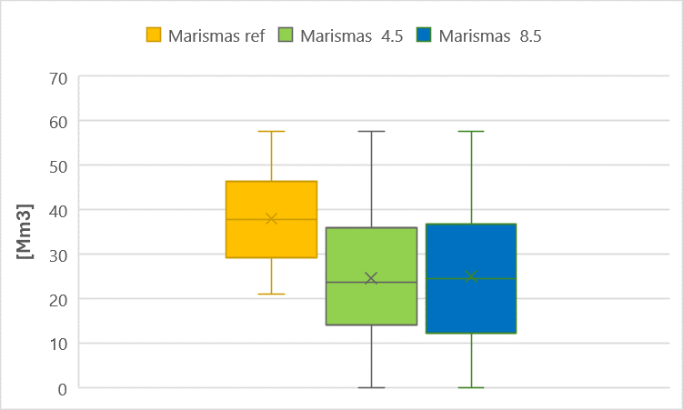

Fig. 4. Analysis of groundwater storage scenarios under the current exploitation regime for the RCP 4.5 and RCP 8.5 and reference climate (ref).

These results are indicative of the usefulness of the relationship between supply and demand over time, in conditions of climate change and then on the mitigation strategies to be adopted in some of these aquifers. The quantitative outputs of the WEAP modelling can allow to calculate relevant indicators to characterize the water exploitation patterns in this case study and put it in relation to other pilot cases, both as input for the second phase of the participatory process. In the scope of the study in fact, a series of Water Accounting Indicators (WAIs) has been defined in order to monitor the parameters related to the key challenges of the Doñana pilot area, which have been determined according to the stakeholder engagement workshops. The general WAI list considered has been derived from the collective indicator archives of the European Environment Agency (EEA, 2022), the United Nations Educational, Scientific and Cultural Organization (UNESCO, 2022), and the World Bank (WB, 2022) and narrowed down to the actual WAI list for Doñana pilot area according to the pilot’s key challenges and data availability (Table 1). In addition to providing a comparison of the current situation of the case study, WAIs allow the assessment of future conditions through their calculation applied in different climate scenarios.
A second very interesting aspect that emerged from the WEAP modelling is the need to obtain quantitative indications about the environmental needs belonging to significant demand nodes in this type of system, such as marshland. This problem is counted among the results of this work because it has suggested the next developments in the proposed methodology. In fact, it has been recognized the need to implement a specific model that would represent few single and crucial environmental nodes.

Table 1. Monitored WAIs list for Doñana.

No. | Water Accounting Indicator (WAI) | Short description of the indicator | Unit
1 | Sectoral Water Use | Water use percentage of each sector available in the pilot area | %
2 | The total amount of supply | The annual total amount of water supply delivered to each demand site (urban, industrial, agricultural, environmental) | hm³/year
3 | The total amount of demand | The annual total amount of water demand needed by each demand site | hm³/year
4 | Supply-demand ratio | The annual water supply-demand ratio of each sector available in the pilot area | %
5 | Unmet demand | The annual water amount that lacking by each demand site | hm³/year
6 | Reliability of source | The percentage of time that the demand site’s demands have been covered | %
7 | Coverage of demand | The ratio of the amount delivered divided by the flow requirement. | %
8 | Water Exploitation Index (WEI) | The mean annual total demand for surface water divided by the long-term average surface water resources | %
9 | Groundwater Exploitation Index (GEI) | The mean annual total demand for groundwater divided by the long-term average groundwater resources | %

The development of a sectoral model for the marshland water balance becomes crucial to evaluate the human and natural impacts including climate variability. As already mentioned, the marshland of Doñana like many other areas in the world is denoted by extremely variable climatic characteristics both interannual and between one year and another. In such conditions, it is not only difficult to understand whether the environment is under abnormal or physiological stress for the well-being of its ecosystems, but certainly, this assessment cannot be trivialized by fixed values based on current data that do not take into account water mass conservation of the system. Even the minimum and maximum quantities of water needed for the system are to be considered, but this must be done in a dynamic way and not through fixed ranges that are linked to a particular situation (Toronto and Regional Conservation Authority, 2020). Adding another sectoral model to the general model structure is under development using a simplified conceptual scheme (Lee et al., 2020) allowing for a dynamic representation of the wetland water storage as well as its inflows and outflows, though keeping the mathematical formulation as simple as possible. The sectoral hydrological model for the marshland will be validated on historical data and possibly reviewed by ecological local experts in order to consider the environment as a water resource user. The goal to be achieved through this wetland water balance tool is also to assess the effect of climate change and anthropic actions on the environment in the future and to couple it with water allocation modelling.

- Conclusions and overview of future activities
This work has presented a methodological framework for socio-hydrological modelling applied to the Doñana region. The adopted approach is not based on a mere coupling of sectoral models but is the composite result of iterative stakeholder engagement for problem framing, model validation, and scenario analysis. It has been found that the involvement of the stakeholders has guaranteed an indispensable source for the knowledge of the behavioral processes and the identification of the main problems of the area. The monitoring of water-related indicators (in this case WAIs) is an essential part of socio-hydrological modelling to assess the outcomes using accepted metrics to quantify the relevance of the baseline conditions and evaluate the effectiveness of generated scenarios/solutions based on the stakeholders’ perception. Hence the selection of the indicators is also an important process to represent key challenges and the complexity of the Nexus system. While data availability and quality are a common issue in this research topic, sometimes narrowing the extent of the study, working with stakeholders proved that this knowledge can be resolved to some degree with their contributions.
Additionally, WEAP allocation and planning modelling has helped to model underground resources in a demand-based approach but at the same time has allowed, using quantitative data, to shed light on those missing or showing trends worth of attention. Practical application has shown that ecological water requirements of wetland systems cannot be considered in a simplistic manner. The future objectives of our activity include, the implementation of the model focused on the marshland’s hydrological balance and on the marshland’s ecological needs. Therefore, the actual implementation of the scenarios described in this work will also include the suitable representation of wetland dynamics in order to evaluate different forces and different solutions related to the baseline understanding of the Nexus and an improved Nexus-based water management to be implemented in future years.

Acknowledgements
The present work has been funded by the LENSES project (PRIMA Programme, GA n°2041). This paper and the content included do not represent the opinion of PRIMA Foundation, PRIMA Foundation is not responsible for any use that might be made of its content.
References
Aldaya MM, Garcia Novo F, Ramòn Llamas M (2010) Incorporating the Water Footprint and Environmental Water Requirements into Policy: reflections from the Doñana Region (Spain), CRC Press, 400 pp
Buytaert W, De Bièvre B (2012) Water for Cities: The Impact of Climate change and Demographic Growth in the Tropical Andes, Water Resources Research, 48 (8):8503
Confederaciòn Hidrografica del Guadalquivir, Ministerio para la Transiciòn Ecològica y el Reto Demografico (CHG) (2023)Plan Hidrologico de la Demarcaciòn Hidrogràfica del Guadalquivir 2022-2027
De Roo A, Trichakis I, Bisselink B, Gelati E, Pistocchi A, Gawlik BM (2021) The Water-Energy-Food-Ecosystem Nexus in the Mediterranean: Current Issues and Future Challenges, Frontiers in Climate, 3:782553
Diaz-paniagua C, Aragonés D (2015) Permanent and temporary ponds in Doñana National Park (SW Spain) are threatened by desiccation, Limnetica, 34 (2), 407-424
EEA (2022). European Environmental Agency. Indicators, https://www.eea.europa.eu/ims
Erwin KL (2008) Wetlands and global climate change: the role of wetland restoration in a changing world, 17, 71-84, (2009)
Falkenmark M, Wang-Erlansson L, Rockstrom J (2018) Understanding of water resilience in the Anthropocene, Journal of Hydrology X, 2 (2019) 100009
Gallant AL (2015) The Challenges of Remote Monitoring of Wetlands, Remote Sensing, 7(8), 10938-10950
Garcia Novo F, Alonso Vizcaino EM, Marin Cabrera C (2005) Doñana: water and biosphere, Doñana 2005 Project, Guadalquivir Hydrologic basin Authority,365 pp
Gil Gil T, Schmidt G et al. (2024) Science to save Doñana.Evidence of its ecological degradation in 2024, WWF Spain
Green AJ, Bustamante J, Janss GFE, Fernandez-Zamudio R, Dìaz-Paniagua C (2016) The Wetland Book, Springer
Green AJ, Guardiola-Albert C, Bravo-Utrera MÁ et al. (2024) Groundwater Abstraction has Caused Extensive Ecological Damage to the Doñana World Heritage Site, Spain. Wetlands 44, 20
Hamdan ANA, Almuktar S, Scholz M. Rainfall-Runoff Modeling Using the HEC-HMS Model for the Al-Adhaim River Catchment, Northern Iraq. Hydrology. 2021; 8(2):58. https://doi.org/10.3390/hydrology8020058
Karamouz M, Barkhordari H, Ebrahimi E (2021) Dynamics of Water Allocation: tradeoffs between allocator’s and farmers’ benefit of irrigation practices, Journal of Irrigation and Drainage Engineering Online 147(6)
Lee O, Kim HS, Kim S (2020) Hydrological simple water balance modeling for increasing geographically isolated doline wetland functions and its application to climate change, Ecological Engineering,149,105812
Naranjo- Fernandez N, Guardiola Albert C, Montero-Gonzalez E (2018) Applying 3D geostatistical Simulation to Improve the Groundwater Management Modelling of Sedimentary Aquifers: The Case of Doñana (Southwest Spain), Water 2019,11,39
Naranjo-Fernandez N, Guardiola- Albert C, Aguilera H, Serrano-Hidalgo C, Montero-Gonzalez E (2020) Clustering Groundwater Level Time Series of the Exploited Almonte-Marismas Aquifer in Southwest Spain, Water 2020, 12,1063
Portoghese I, D’Agostino D, Giordano R, Scardigno A, Apollonio C, Vurro M (2013) An integrated modelling tool to evaluate the acceptability of irrigation constraint measures for groundwater protection, Environmental Modelling & Software 46 (2013) 90-103
Sahu, M.K., Shwetha, H.R. & Dwarakish, G.S. State-of-the-art hydrological models and application of the HEC-HMS model: a review. Model. Earth Syst. Environ. 9, 3029–3051 (2023). https://doi.org/10.1007/s40808-023-01704-7
Sušnik J, Masia S, Indriksone D, Bremere I, Vamvakeridou-Lydroudia L (2021) System dynamics modelling to explore the impacts of policies on the water-energy-food-land-climate nexus in Latvia, Science of Total Environment, 775, 0048-9697
UNESCO (2022). United Nations Educational, Scientific and Cultural Organisation. Indicators. https://unesdoc.unesco.org/ark:/48223/pf0000371562
Yates, D., Sieber, J., Purkey, D., & Huber-Lee, A. (2005). WEAP21—A Demand-, Priority-, and Preference-Driven Water Planning Model: Part 1: Model Characteristics. Water International, 30(4), 487–500. https://doi.org/10.1080/02508060508691893
Wetland Water Balance Modelling Guidance Document (2020) Toronto and Region Conservation Authority
World Bank (2022). Indicators, https://data.worldbank.org/indicator

